Ever since the inception of GNOME and KDE there has been confusion among new Linux users which is which and which is best to use. The former question is fairly simple to answer. The latter question, however, is a bit more complex due to user-specific needs/wants.

With that in mind let us begin by illustrating the differences between a desktop environment and a window manager. We'll begin by showing how the Linux graphical desktop is layered.

As you can see, in the image below, there are basically three layers that can be included in the Linux desktop:

* X Windows - This is the foundation that allows for graphic elements to be drawn on the display. X Windows builds the primitive framework that allows moving of windows, interactions with keyboard and mouse, and draws windows. This is required for any graphical desktop.
* Window Manager: The Window Manager is the piece of the puzzle that controls the placement and appearance of windows. Window Managers include: Enlightenment, Afterstep, FVWM, Fluxbox, IceWM, etc. Requires X Windows but not a desktop environment.
* Desktop Environment: This is where it begins to get a little fuzzy for some. A Desktop Environment includes a Window Manager but builds upon it. The Desktop Environment typically is a far more fully integrated system than a Window Manager. Requires both X Windows and a Window Manager.

A Desktop Environment generally includes a suite of applications that are tightly integrated so that all applications are aware of one another. A Desktop Manager will also include some form of panel that includes a system tray where small widgets can be placed for quick action or information.

[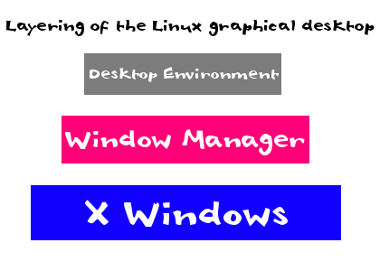](http://cdn.ghacks.net/wp-content/uploads/2008/12/desktop_layers.png)

Linux Desktop Layering

Much of the confusion starts to peek out when you examine such Window Managers as E17 (Enlightenment 17).

The most recent iteratio of Enlightenment includes many of the elements usually found only Desktop Environments even though Enlightenment is still considered a Window Manager. To this point I generally refer to such desktops as Desktop Managers.

There are two main Desktop Environments: GNOME and KDE. If you are curious as to which is right for you, here is some advice. The latest default GNOME will make users of OS X feel right at home, KDE 3.x will make Windows XP users feel at home, and KDE 4.x will make Windows Vista users feel at home.

As to which Window Manager is best suited for which user? Since there are so many Window Managers I will highlight my favorites.

* [Enlightenment](http://www.enlightenment.org): You want plenty of eye candy but not something as resource-intensive as [KDE](http://www.kde.org) or [GNOME](http://www.gnome.org/).
* [Fluxbox](http://www.fluxbox.org): You want minimal and fast.
* [Afterstep](http://afterstep.org/): You want something old-school to give you hours of tinkering fun.
* Xfce: You want a Windows-like interface without the bloatware of GNOME or KDE.
* [Compiz-Fusion](http://www.compiz.org/): This is a full-blown 3 dimensional window manager rife with plugs that do just about everything. If you want something to seriously impress your friends, this is where you want to look.

One of the most wonderful things about the Linux desktop is that it is only limited to your imagination. You can make the Linux desktop look and feel exactly how you want it. You can go from complete minimalism to the full-blown 3D goodness of Compiz-Fusion. I will give you one warning: Playing with the Linux desktop might be as much of a time-suck as World of Warcraft.